1. Convert the mailorder-schema.xml into an equivalent json document called mailorder.json. Note that there are different ways to model and transform a given xml document to a json document. Choose the one that makes sense to you.

Mailorder.json is attach in d2l.

1. Load the json document from step 1 into your mongo database. Give the command(s) that you used to load into the mongo database. Also, submit the screenshot of your execution.

Command to import to jsaon file in mongodb is

mongoimport --db Mialorder --collection Mialorder --type json –file D:\Master\Sem1\MSCS6380\Assignment4\mailorder.json –jsonArray

1. Answer the following as Mongo queries. Submit screenshot of the execution of your queries

a.      Get the names of parts that cost less than 20.00.

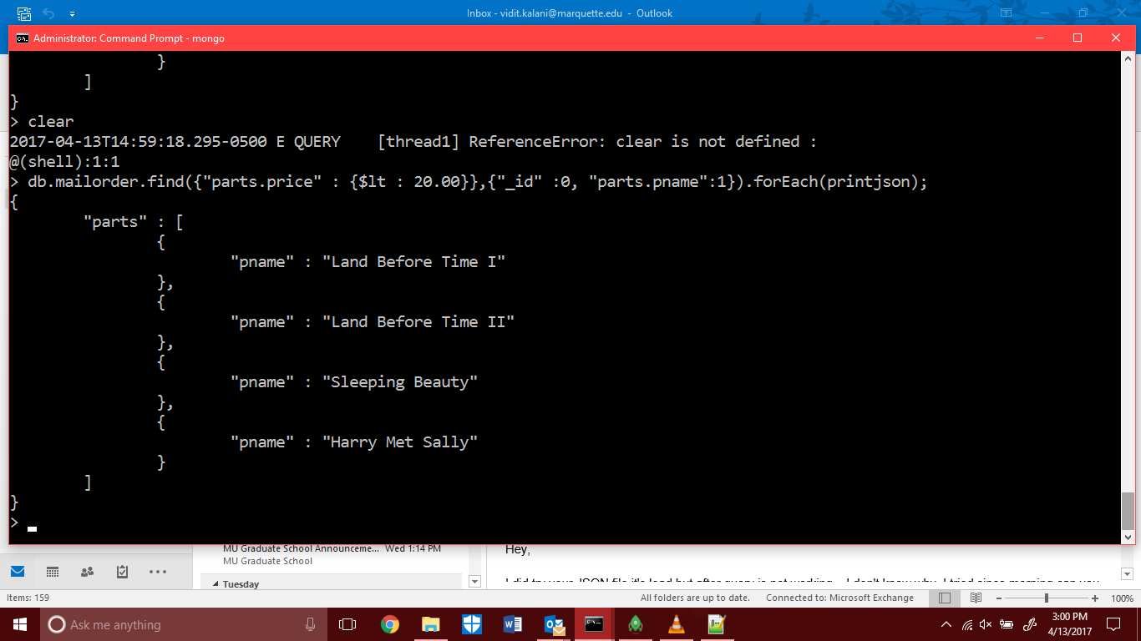

b.      Print the names of employees who live in Wichita

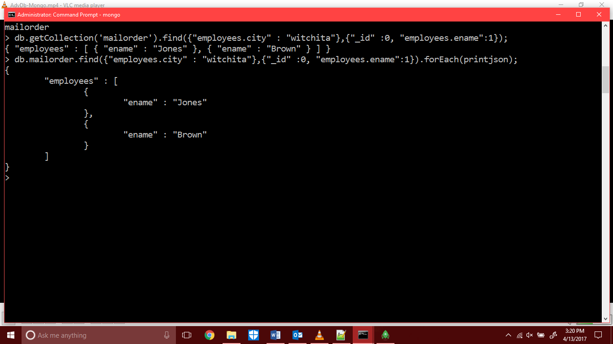

c.       Get the names and phone numbers of all customers

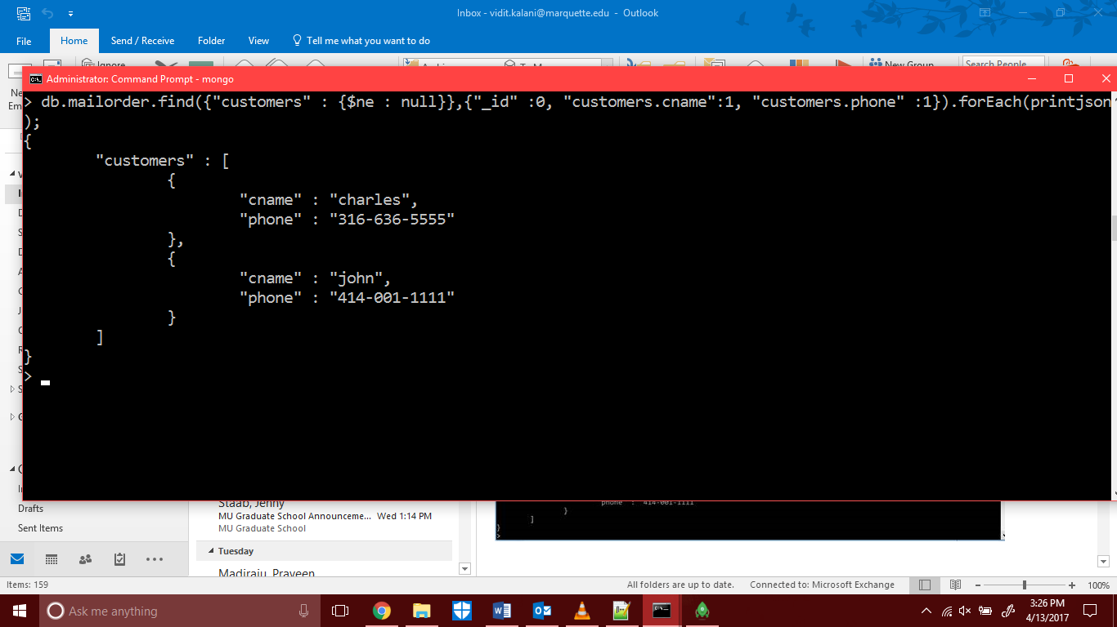

1. Give commentary on how joins and grouping expressions are implemented in mongo. Cite your work. Show a sample join and a group by query that you have implemented on the mailorder mongo database. Submit any relevant files and screenshot of the execution of your queries.

db.mailorder.aggregate([{$lookup:{from: "customers", localField: "cname", foreignField: "pno", as: "cname_docs"}}])

